**Automated ticket generator for calculating profit or loss by date**

**(i) Create a conceptual model (ii) implement database using SQL (iii) use PL/SQL**

(i)Physical Model

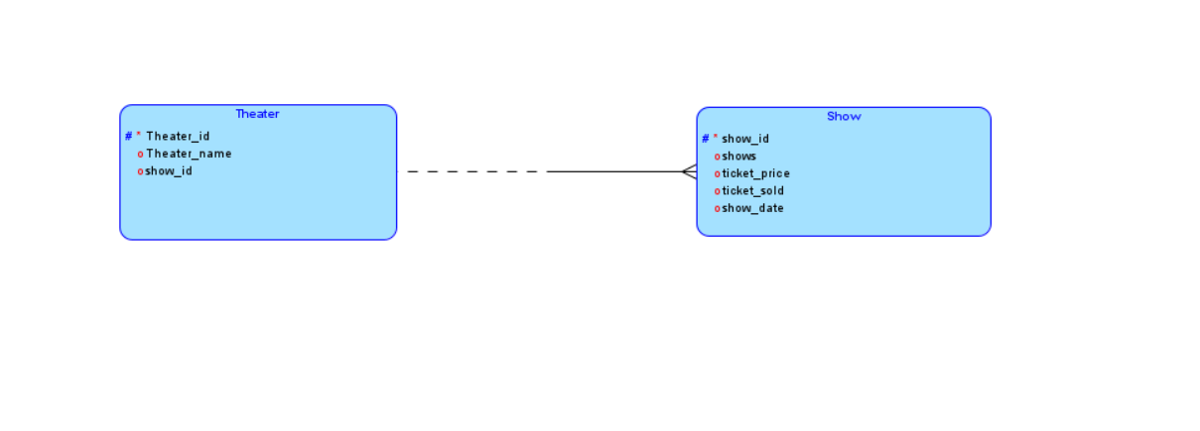

Relational Model

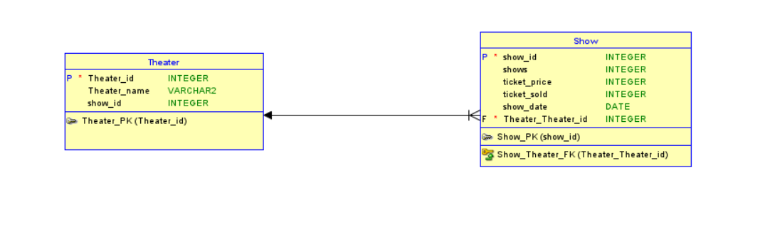

(ii)

CREATE TABLE Theater(theater_id NUMBER PRIMARY KEY,theater_name VARCHAR2(20),show_id NUMBER);

INSERT INTO Theater VALUES(1,'Theater 1',101);

INSERT INTO Theater VALUES(2,'Theater 2',102);

INSERT INTO Theater VALUES(3,'Theater 3',103);

INSERT INTO Theater VALUES(4,'Theater 4',104);

SELECT * FROM Theater;

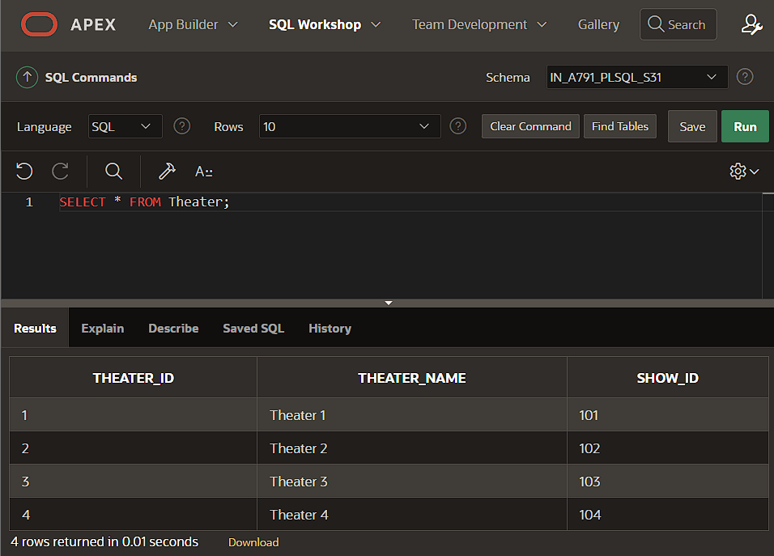

CREATE TABLE show(show_id NUMBER PRIMARY KEY,shows NUMBER,ticket_price NUMBER,ticket_sold NUMBER,show_date DATE,theater_id NUMBER,FOREIGN KEY (theater_id) REFERENCES Theater(theater_id));

INSERT INTO show VALUES(101,3,120,300,TO_DATE('2024-08-15', 'YYYY-MM-DD'),1);

INSERT INTO show VALUES(102,3,120,270,TO_DATE('2024-08-17', 'YYYY-MM-DD'),2);

INSERT INTO show VALUES(103,3,120,160,TO_DATE('2024-08-14', 'YYYY-MM-DD'),3);

INSERT INTO show VALUES(104,3,120,255,TO_DATE('2024-08-18', 'YYYY-MM-DD'),4);

SELECT * FROM show ORDER BY SHOW_ID;

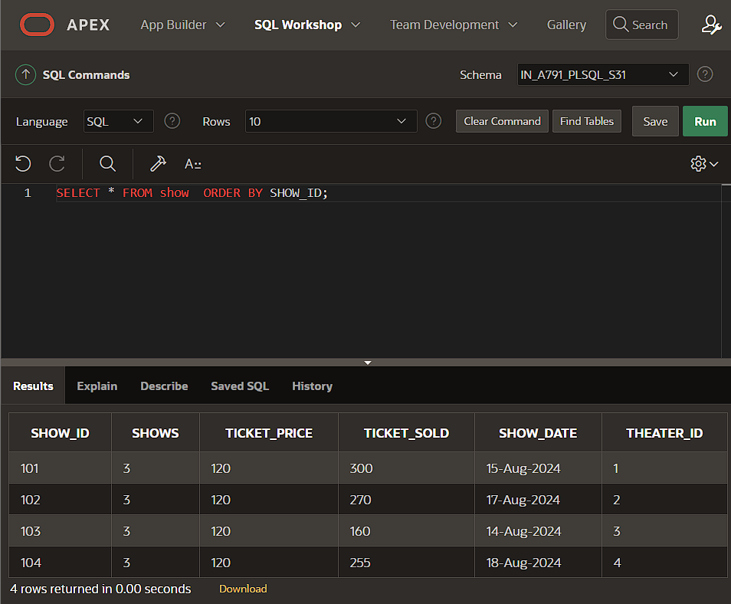

(iii)

CREATE OR REPLACE PROCEDURE Calculate_Profit_Loss IS

income NUMBER;

expenses NUMBER := 90000;

r NUMBER;

profit_loss VARCHAR2(20);

CURSOR c1 IS

SELECT s.shows,s.ticket_sold,s.ticket_price,s.show_date,t.theater_name,t.show_id FROM Show s JOIN Theater t ON s.theater_id = t.theater_id;

BEGIN

FOR s IN c1 LOOP

income := s.ticket_sold * s.ticket_price * s.shows;

r:= income - expenses;

IF r>0 THEN

profit_loss := 'Profit';

ELSE

profit_loss := 'Loss';

END IF;

DBMS_OUTPUT.PUT_LINE('Show Date: '||TO_CHAR(s.show_date, 'YYYY-MM-DD')||' | Theater: '||s.theater_name||' | Net Profit/Loss: '||profit_loss);

END LOOP;

END;

/

BEGIN

Calculate_Profit_Loss;

END;

/

